Practical No:06

**Aim:** File Operations

a) Explore mounted filesystems on your system

**Using findmnt command**

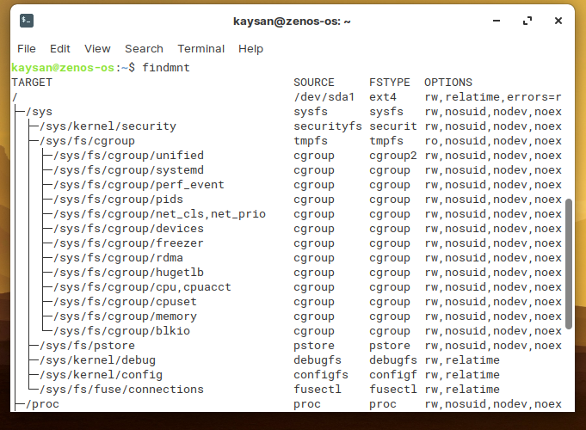

b) What are the different ways of exploring mounted filesystem on Linux?

**Finding mounted filesystem type by using blkid command**

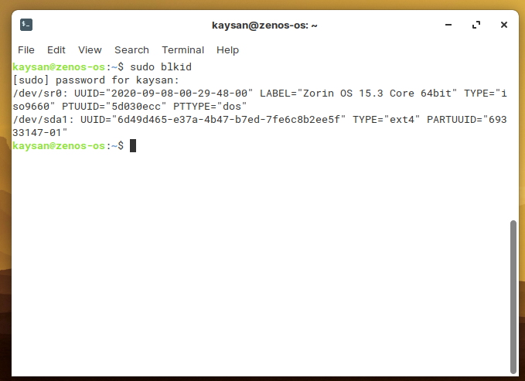

**Finding mounted filesystem type by using df command**

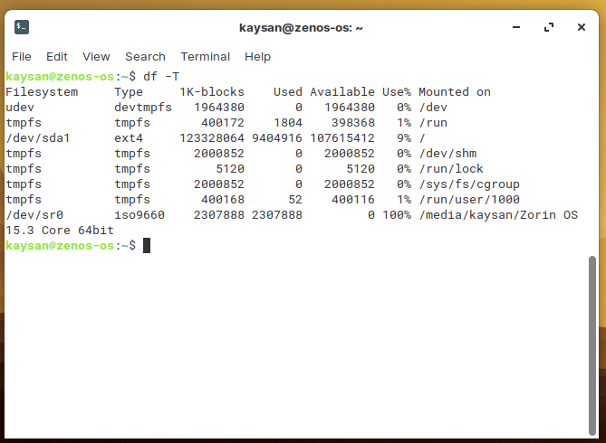

**Finding mounted filesystem type by using lsblk command**

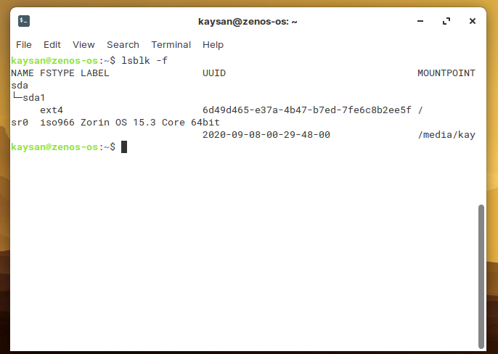

c) Archive and backup your home directory or work directory using tar, gzip commands

**Using tar command**

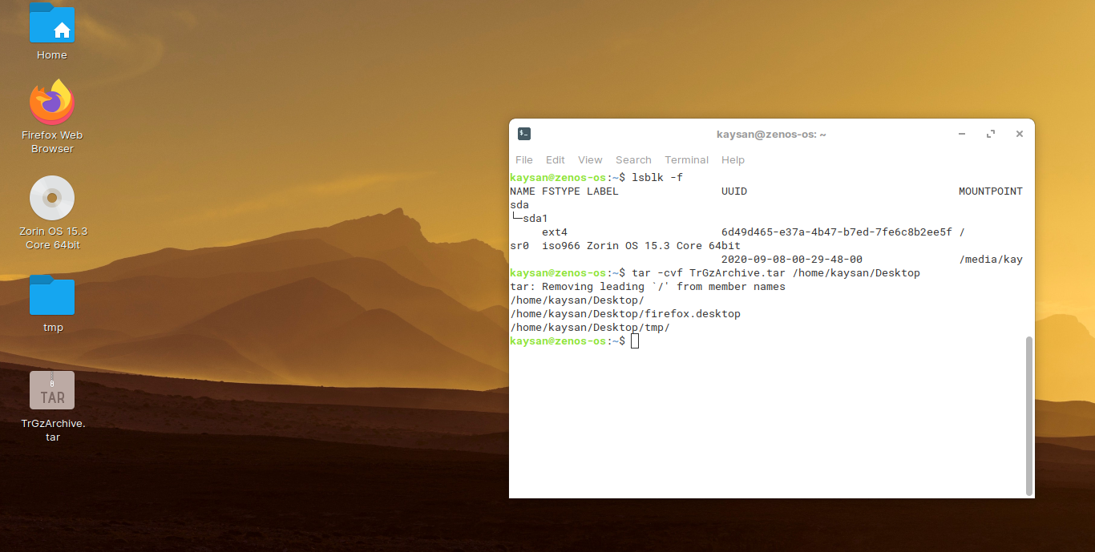

**Using gzip command to compress**

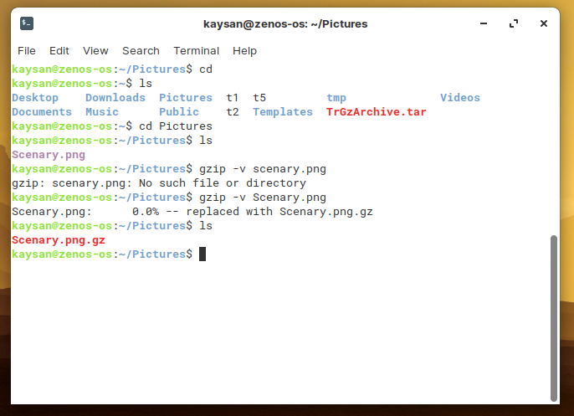

**Zipped file can be created using zip command**

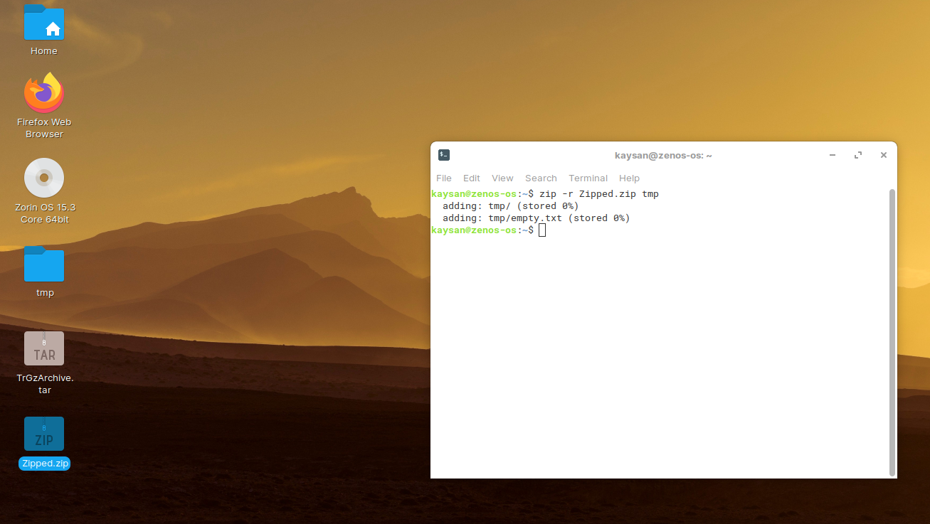

d) Use dd command to create files and explore different options to dd

